Index / Position in Strings

Definition:
# Source: AI Source: Provided by: [Data Path: Persons Table -> ID Column: 1, Name_En Column: Motasem Essam] -> From: [ChatGPT] on [1/26/2026]
The index (or position) of a character in a string is the numeric location of that character within the string. It is used to access or manipulate specific characters.

Key Points
# Source: AI Source: Provided by: [Data Path: Persons Table -> ID Column: 1, Name_En Column: Motasem Essam] -> From: [ChatGPT] on [1/26/2026]
- Indexing usually starts at 0 (first character has index 0).
- Negative indexing is supported in some languages (like Python), where -1 refers to the last character, -2 to the second last, and so on.
- Index allows direct access to characters in a string or array.

Example
# Source: AI Source: Provided by: [Data Path: Persons Table -> ID Column: 1, Name_En Column: Motasem Essam] -> From: [ChatGPT] on [1/26/2026]
Python
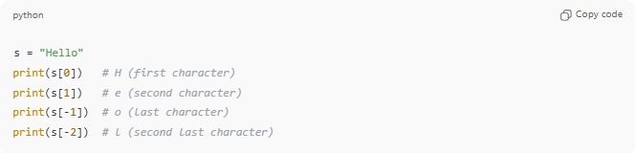
s = "Hello"
print(s[0]) # H (first character)
print(s[1]) # e (second character)
print(s[-1]) # o (last character)
print(s[-2]) # l (second last character)
C / C++
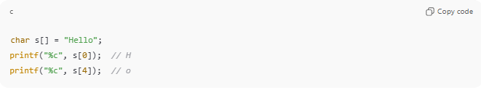
char s[] = "Hello";
printf("%c", s[0]); // H
printf("%c", s[4]); // o

Accessing Substrings Using Index
# Source: AI Source: Provided by: [Data Path: Persons Table -> ID Column: 1, Name_En Column: Motasem Essam] -> From: [ChatGPT] on [1/26/2026]
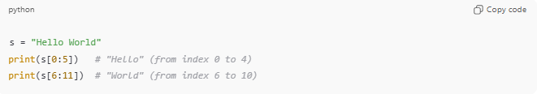
- Index is also used for slicing / extracting substrings.
s = "Hello World"
print(s[0:5]) # "Hello" (from index 0 to 4)
print(s[6:11]) # "World" (from index 6 to 10)

Analogy
# Source: AI Source: Provided by: [Data Path: Persons Table -> ID Column: 1, Name_En Column: Motasem Essam] -> From: [ChatGPT] on [1/26/2026]
- String → A row of boxes containing letters
- Index → The number assigned to each box
- You can pick or modify the content of any box using its index

✅ Summary
# Source: AI Source: Provided by: [Data Path: Persons Table -> ID Column: 1, Name_En Column: Motasem Essam] -> From: [ChatGPT] on [1/26/2026]
- Index / Position = location of a character in a string
- Usually 0-based
- Supports negative indexing in some languages
- Used for accessing, modifying, or slicing strings

